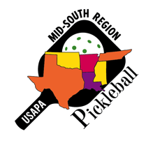
MID-SOUTH REGION NEWSLETTER
March 2017

We want to welcome four new ambassadors to the Mid-South…all from Texas: Gina Jenkins (Bedford), Susan Henderson (Mesquite), Teena Sandberg (Montgomery), and Mary Simpson (Willis).

Gina has been playing a little over three years in the Dallas area. She has volunteered to be a coordinator for education, growth, and awareness for para PB in our region. Gina is an amputee and has a great love and attitude regarding PB for all ages and abilities. As you might imagine, she is very competitive on the court.

Teena has four and a half years experience in playing the game we love. She played years ago in Jakarta, Indonesia, and upon returning to the states, revived PB in The Woodlands, organized and conducted a clinic with 40 participants at a tennis venue in Montgomery and followed that up with another clinic for 26 players. She has also led practice and a demo for new players. Teena has started a Facebook page, twitter site, and other avenues of social media to get the PB message across. She also has a website (Lake Conroe Pickleball Friends).

Susan has also been playing about three years. She has conducted demos and staff development for the Mesquite ISD secondary physical education teachers. Susan has numerous and specific plans on growing PB at various venues in the towns of Mesquite and Rowlett.

Mary has been playing a little over a year. She has been ‘attacked’ by the PB bug. She is good friends with Teena and has helped with many of the clinics/demos mentioned above. Mary loves to emphasize the fun of the game to new players, with the next endeavor being a PB social. A long- time tennis player, she looks forward to mastering ‘the dink’. Mary wants to promote PB to young and old(er).

Kimberly Barnes (OK City, OK) was recently awarded a USAPA Community Grant to Western Oaks Middle School to provide students in a low-income area the opportunity to play a sport that is open to anyone, no matter their skill level. Great work, Kimberly.

Mike Goldberg (Houston, TX) reports that the First Methodist Church of Houston is beginning a PB program for their member families, the senior center across the street from them, and for any other person who would like to play there. They have four courts in the gym along with wood paddles and PBs. The GREAT news is that play is FREE for the month of April. This site is now listed on the USAPA Places to Play. Fellow ambassadors Mitus Junatas and Ricardo Molina helped Mike with a demo/clinic at the opening of this venue.

Christie Borne (Hot Springs Village, AR) writes: Donde esta estos ninos? Where are these children? They are the children who attend an after- school program every Tue & Thur in a mission of Mezcales, Mexico. Upon an invitation by friends from Michigan to stay with them for three weeks in Nueva Vallarta, Mexico, we planned games for the kids as well as teaching them to play PB. Selkirk, Paddletek, Engage, and Gamma paddles were donated while the Grand Rapids PB Club supplied 120 PBs. I planned a progression of games that led up to the children being able to keep a short PB rally going. During this time, the students learned sportsmanship and how to care for the paddles while standing in line to hit the ball. It was so exciting to see them bumping a ball over the net with one of their friends to create a rally. (Photos below)

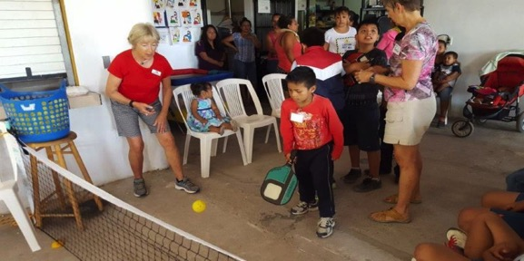

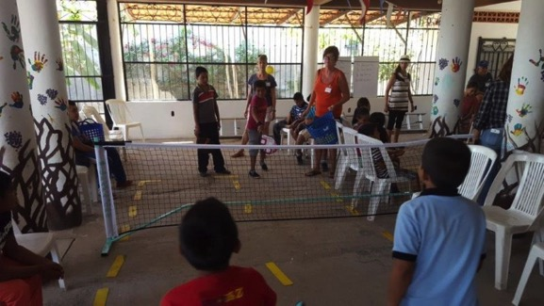

Buddy Todd (Amarillo, TX) is bragging about recently appointed ambassador Dan Dyer, who has already met with the Parks & Rec folks to consider converting an under-utilized tennis court to four outdoor PB courts. Positive progress, Dan.

Lillian Palmer (Weslaco, TX) shares that Palm View Community center in McAllen, TX, is the host to their annual Senior Olympic PB Tourn. A supervisor at the center LISTENED to their needs…to have two skill- level divisions, 3.0 and below and 3.5 +. The total entries doubled from last year and they expect to continue growing next year. It is amazing what one small change will make. Great work, Lillian.

Sharon Richard (Lafayette, LA) notes that a small group of PB players in Alexandria, LA has been playing once a week. The city Parks & Rec Dept have now doubled that opportunity to play an additional day by giving one of the players a key to open the gym. Not only that…the P & R donated a promotional banner, the size of which King Kong might be able to handle. (Kind of reminds me of a certain USAPA banner.:-))

Pat Heurtin (St Francisville, LA) and I taught a class of PB for two hours once a week for six weeks through LSU’s OLLI (Osher Lifetime Learning Institute). This was a fun group to work with. (Picture below). Three or four missed this photo opp.
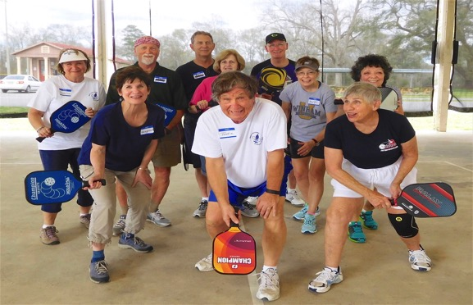

Deonne Linenberger (Biloxi, MS) sends this link of PB TV coverage:
http://www.wlox.com/story/34997803/pickleball-gaining-popularity-on-the-coast

The Louisiana Senior Olympic PB tournament will be April 22, in Baton Rouge. Doubles and Mixed only. Go to: (lsog1.net) for info or to register. This event will be conducted as if it is a sanctioned tournament.

The Mississippi State Games PB tournament is May 5 & 6 in Biloxi. The deadline to register is April 24. Go to: (stategamesofms.org) for info.

The 3rd Annual Heber Fever PB tournament in Heber Springs, AR will be Aug 17-19. Go to: (heberspringsparksandrec.com) for more info.

I am happy to report that Tim Dean (Cedar Park, TX) has answered Larry Honeycutt’s prayers and taken over the Mid-South Website.
(http://midsouth.usapa.org/). I want to thank Larry for creating the website as well as keeping it going for several years. Larry is largely responsible for making it much easier for us to complete everything related to nominating and the committee choosing our annual Pickleball Pioneer award winner. Tim, meanwhile, has already made some minor changes and will continue to do so.
Tim has opened our new Facebook page (Mid-South Regional USAPA). We hope all of you will Like this page and recommend it to all your PB friends. This could really help when trying to pick a potential tournament date for a local tournament in our region.

The State Games of LA tournament went well with Jenn Pugh running the operations table and Winnie Montgomery handling the refs.

Our 9th USAPA Mid-South Regional was a success, with many outstanding matches. We were able to have just about everyone play small round robins for seeding purposes and then move on to bracket play, which provided lots of court time for most players. Thanks to Roger Workman, Fred Thompson, Winnie Montgomery, Chuck Flanagan, Linda Neill, Sharon Richard, and Larry & Jo Honeycutt for making everything run smoothly. And a BIG THANK YOU to those of you who promoted and/or participated this year.

This has been a busy March for me. I have participated in the St Games of LA, Mid-South, Berwick, and Mid-America tournaments in addition to two weeks of OLLI classes.

It is getting warmer. Don’t forget to hydrate, especially when playing outside.

tom

