MID-SOUTH REGION NEWSLETTER
Feb-17

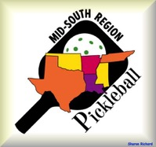
We have three new additions to our ambassador family: Ernie Ortiz (Conroe, TX), Dale Workman (New Orleans, LA), David Hart (Columbia, TN), and returning former ambassador, Christina Dorman (at large).

Ernie has been playing about two years and has helped with clinics at his local recreation center. He is also trying to develop PB at the college level in Belton, TX. One of his goals is to meet with local community leaders to help add PB courts or convert rarely used tennis courts to PB. He has just retired from the outstandingly relaxing job of being an Air Traffic Controller. Well deserved, I’m sure.

Dale has been playing almost a year and a half and is completely taken with PB. He plays at the Hilton Health Club of the Riverside Hilton in New Orleans. He gets to promote and play with many tourists who are visiting the area. He has conducted several demos as well. Dale also sees the importance of exercise and the health benefits of our sport to all ages.

David is a long time tennis player who is making the move to PB (six months). He regularly teaches beginners to play at the Spring Hill Rec Center. He notes that there are about 35 regulars and it seems as though new participants appear on a continual basis. In addition to playing inside, new outdoor courts are being built at the present time. David has helped with a demo, and hopes to help promote PB through his video filming and editing hobby. Lastly, David wants to use these skills to help demonstrate the need for more courts in several nearby areas.

Christina is an excellent player and teacher of PB. We are glad to have her return as an ambassador.

Charlotte Rivera (District Ambass. NE & NCen TX) sponsored another Ref Training Course taught by USAPA Certified Ref Instructor Fred Thompson earlier this month. There were right at 25 participants at The Summit in Grand Prairie, TX, Pretty soon, we will be looking at fantastic growth of certified refs in this area of Texas.

Rich Karakis (Knoxville, TN) sends this link of a front-page story from a local newspaper featuring area kids being introduced to PB. Good job, Rich. http://www.tellicovillageconnection.com/eedition/

Jenn Pugh (DA, MS) & Deonne Linenberger (Biloxi, MS) furnished this PB video link that was shown on their local news channel:
http://www.wlox.com/story/34515459/pickleball-growing-in-popularity?utm_content=buffer19c23&utm_medium=social&utm_source=facebook.com&utm_campaign=buffer

Rommie Maxie (Richmond, TX) shares the following:
Here is a picture of the Sweetgrass Pickleball Club participants.
Left to right- Dan Madsen, Dave Howard ( silver medal) , Kenji Nishioka (
gold medal) , Gary Smith ( silver and bronze medal), Lynn Whelan, Steve
Harris ( gold and silver medals) , Paula Hopkins ( gold medal), Rommie
Maxey.
We also have a Family Fun Day planned for Mar 14 ( children and
grandchildren) , hot dogs, chips and drinks after clinic and play.
Also a Social Tournament for players and families to watch and play, April
2nd.
Working with other Texas 55+ communities to play on a reciprocal basis.
Continue to have many players entering Tournaments in Texas and Louisiana.
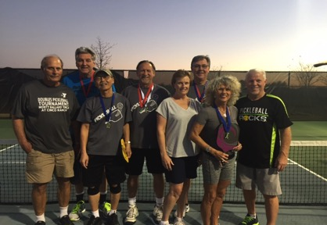

Jim McPherson (Hot Springs Village, AR) reports that The Mid-America Indoor Championships registration is well over 250 of the 300 cutoff point. Info at: pickleballtournaments.com

Tim Dean (Cedar Park, TX) notes that his Cedar Park Paddle Battle in May is filling up fast, as well. Info at: http://www.pickleballtournaments.com/welcome.pl?tid=1095#1

Carol Call (Lubbock, TX) encouraged fellow player Jarrod Haddon to apply for a USAPA Grant and …it was accepted. Great job, Jarrod. Hopefully, you will soon have two additional courts to play on.

Vicki Bruce (Brenham, TX) also received a USAPA Grant. After being offered an indoor venue, the Brenham Paddle Pushers will now have more equipment, not to mention courts to use and play on. Great job, Vicki, your grant was well written.

The NSGA national tournament in Birmingham, AL early registration deadline is Feb 28th at midnight.

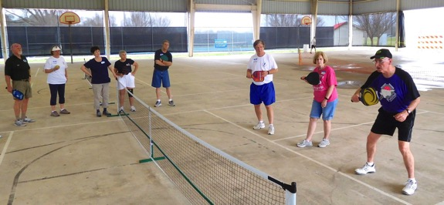

Pat Heurtin (St Francisville, LA) hosting a weekly (for six weeks) PB class. (above)

Members of our Mid-South Region Committee have voted to begin a nominal charge for use of our 16 net systems. In the past, we have allowed free use of them. However, the wear and tear of extended use over the last 6-7 years has caused us to now charge $10 per net system per tournament. We have already had to replace the nets only on two systems, and another net that was not returned with the bag and system. Our net systems have been used by many groups for their tournaments. We will continue to include a yardstick that will hang on a net post and, of course, the handy dandy hanging ziplock ball bag. Thanks for your consideration in this change of policy.

Due to a liability issue, you are reminded not to hang USAPA banners in any PB venue (indoors or outside) unless there is an official USAPA sanctioned event being conducted at the time. However, you may have a USAPA membership table at a non-sanctioned event and hang said banner from that table.

Director of Ambassadors, Carrie Jermstad, wishes to remind all players of the St. Jude National Indoor Pickleball Classic & Challenge Team Event (May 22-24). The event will be held in Emerson, Ga, which is about 40 minutes north of Atlanta or about the same time south from Chattanooga, TN.

All proceeds and denotations benefit the St. Jude Children’s Research Hospital.

Events include Men’s, Women’s, & Mixed Doubles, Men’s and Women’s Singles Age/Skill Grooups (when possible)- 19+. 50+, 65+, 80+ plus a special St Jude challenge team event (one paddle, 2 women and 2 men, singles format.

Format…Double Elim—Round Robin for brackets with 4 or less teams.

Registration is now open at: pickleballtournaments.com

In my part of the world, tomorrow is Mardi Gras. So have a happy one.

tom

