MID-SOUTH REGION NEEWSLETTER
April-17

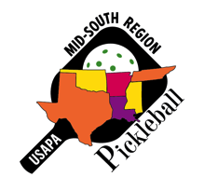
I want to welcome Clayton Edwards of Ada, OK to our family of ambassadors in the Mid-South. He has been playing about two years and as a ‘younger’ participant (as opposed to seniors) he hopes to recruit more of his peers as well as others of all ages.
Clayton wants to secure an indoor facility to play in weekly. He has already talked with two different wellness centers and several local church gyms about hosting PB. He would like to find one venue to use on a weekly basis and really grow the game there. Having played tennis for several years, he now has many friends that seem to be interested in PB as well.

Gus Nezer of Keller, TX is another recently added ambassador. Although he has been playing a little over two years, he is very close to completing his certification as a Certified PB Training Professional with the IPTPA. He plays 4-5 times per week and has developed a solid network of others who enjoy the sport. He has also introduced several dozen people of all ages to PB and believes that PB is a rare sport in that it offers people of all ages an opportunity to play together (across a wide age spectrum) to get some great exercise, not to mention having fun.
Gus has helped with demos/clinics with fellow ambassador Ernie Ortiz. Additionally, Gus just wants to introduce PP to as many people as he can.

Randy Godwin (Mountain Home, AR) applied for and has received a $250 grant from the USAPA. With the current venue having only two courts and too many participants with limited times to play, Randy found the ‘Youth Center’ with the potential for six PB courts plus morning and evening times. The morning time will be available for seniors while the evening time will be for younger players. Additionally, Randy will begin some youth PB programs at the center this summer. Congratulations, Randy. (BTW, I received a report recently that shows the Mid-South is 5th out of 8 regions in receiving grants. The grant process is not difficult. I am sure some of you can find a venue that does not have PB, and can then take advantage of the USAPA grant. Once the grant money is used for the year, you must wait until next year).

Carla Norris Hopkins (Little Elm, TX) writes the following:
Ambassadors, Pickleball medalists and advanced Pickleball players from Little Elm, McKinney, and Flower Mound, Texas came together to teach middle school students the wonderful game of Pickleball.
Several months ago I contacted the school principal of Colin Powell 6th Grade Center in Little Elm, Texas and asked if we could introduce this fast growing sport of Pickleball to her students. She loved the idea and passed it along to the PE teacher, who not only wanted us to teach her 6th grade class but also teach another PE teacher's combined 7th and 8th grade class. The results was three full days of classes - the largest having over 45 students at one time.
Many thanks to the volunteers who taught, guided, motivated and even ignited self-confidence in many of the students. Their passion was contagious. Their skill amazed the kids. (Just as their skill with social media and new technology amazes.)
Much appreciation to Juanita Vincent, USAPA Nationals Gold Medal winner who teaches skill and drill clinics to youth and adults in McKinney, Texas, for teaching the classes and also providing much needed paddles and a net. Gold medalist and Ambassador Angela Luhman of Flower Mound, TX for teaching on the last day of classes as well as help setting up the courts. Trophy winner and Advanced player Johnny & Juana Carabajal (Little Elm), Medalist Bob Shechan (Little Elm), Ambassador and medalist Sherri Eubank (McKinney) for working so patiently with the kids individually and in teams.
So grateful to Ellen Gilgore of Robson Ranch for answering my many questions and offering good advice on what to expect - since she successfully brought Pickleball to the Argyle schools. She also loaned us much-needed balls and paddles. Thanks to Susan Sage and Greg Odor of Little Elm for helping set up and tape the courts along with Angela, Bob and Johnny. Thanks to District Ambassador Charlotte Rivera for loaning a much-needed net.
Several students asked that we come back next week - and some wanted to know where they could play right away. The students and teachers liked the games so much that the Principal said it would be great if we come back next year.
Since the classes ended there are now plans to have a youth Pickleball night at the local Recreation Center. This is a great start to what I hope and believe will lead to regular Pickleball classes in the schools and opportunities for the youth to play regularly in the community and even the Olympic games one day. (Fantastic job, Carla).

Jamie Elliott (McKinney, TX) notes: My second home , here in Dallas, is in a 55 or older community with 4 tennis courts. I have owned here for 11 yrs, and the tennis players have put their tennis shoes down and have said, "No extra lines on OUR tennis courts.” Well, I believe our management is seeing too many older, non golfers buying homes in here and are worried about this community. It is built out, and I guess not a lot of golf memberships are being sold. Soooo..... now and talked to them about my involvement and now we have a meeting scheduled on April 12th. We have about 12 players living out here and we travel to McKinney, (15 min away) to play.

David Hart (Columbia, TN) shares this photo.
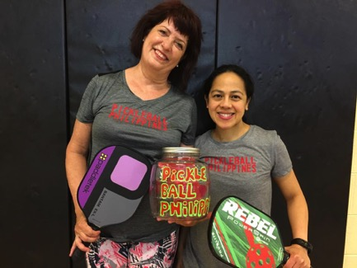

Delia Box (left) has been raising money for Shanna Uppermann (right). Shanna returns to the Philippines to visit her parents and teaches classes while she is there. Delia has raised $300 for Shanna to use buying Pickleball equipment that she can leave behind with the new players. Both women are regulars at Longview Recreation Center in Spring Hill, TN. Submitted by David Hart - Ambassador for Maury County, TN.

Mary Hodge (Richardson, TX) notes that one of her local players (Barrett Kincheloe) has developed a website as a resource for beginning and advanced players. (The info contained that I looked at was easy to read and understand and written in a logical way, presented not only the ‘how tos’, but also the ‘whys’). The site can be found at (pickleballgenie.com).

Mary Simpson (Willis, TX ) and Tenna Sandberg (Montgomery, TX) share that they hosted their first ladies night PB social that was very successful, including both brand new players as well as seasoned players. The players at April Sound CC and their Lake Conroe PB friends have grown to over 30 players. “Can you believe we are buying more nets?” (YEP)

Dan Dyer (Amarillo, TX) reports that the indoor PB group is growing slowly. We use the 4 courts three times a week to just about maximum. They are at the big Trinity Baptist Church gym.

I’ve had several meetings with Amarillo Parks and Rec. Buddy (the other Ambassador here) and others have attended as appropriate. The City has committed to giving us one tennis court for conversion. The tennis court is rather tightly packed with another tennis court, and we are not able to work a way for more than two courts for now. But if we get a second tennis court later, we can probably go for a total of six PB courts. At first, the plan was for the City to provide materials and the PB players would do the painting. Now the City has said they will patch the somewhat rough surface and do all the painting using a contractor.

They’ve given us a tentative completion date of June 1, and with that proposal they have given me the go-ahead to start promoting the game with various social groups in the City. I’ll be collecting names and contact information so that we can begin training new players shortly after the “grand” opening. I’m hoping for a big surge in players so we can take a second court. I did a City inventory using Google maps and all. There are about 130 tennis courts in the City and about 80 are still in somewhat decent shape. They won’t miss a few tennis courts. The main tennis center in town (with 2 indoor and maybe a dozen outdoor courts) is very poorly used. I rarely see more than eight cars parked there. But, as in any tennis center, there is some denial of lack of use.

Guess who got certified as USAPA refs…Congratulations Bob and Irene Romagosa.

Don’t forget about the St. Jude National Indoor PB Classic May 22-24. Emerson, GA is about 40 minutes north of Atlanta and about 45 minutes south of Chattanooga on I-75. Go to pickleballtournaments.com to register or for information.

As you may know, The 2018 Ambassador retreat will be Jan 28-Feb 2, in Port St. Lucie, FL. This event was held there last year and was well received by the attendees. Registration begins May 17th. There was lots of PB, networking, eating good food, seminars, etc. this past year. I hope to see you there.

Pat Heurtin (St Francisville, LA) shares this picture of one of her younger PB players…her great grandson, Lliam (age 4).

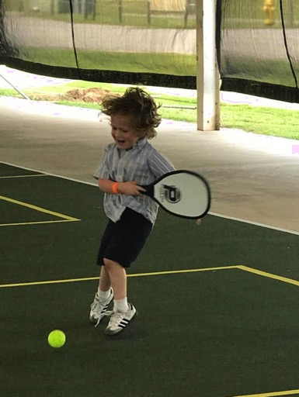

I am excited to inform you of upcoming additions to the Mid-South website. The goal is to provide a list (by date) of every (or as many as you can/will send us) PB tournaments in our region. Many times, another venue might be hosting their own tournament as well. So instead of possibly having two strong tournaments a few weeks apart, we have had two smaller tournaments on or very near the same date, thus diluting participation from each other. Hopefully, this will help in the above example from happening as often. There are plans to also note if the tournament is sanctioned or not, indoors or outside, age, skill, or both, date/s, and possibly some other quick fact info re the event.

In conjunction with the above, we are also looking at adding a partner search for the above tournaments. Remember, the only events listed will be in the Mid-South. Of course, you can still list your name on the USAPA website, and/or your tournament as well. We hope this will help all events in the Mid-South through better communication.

I have had a pretty busy April. On April first, I participated in the Greater New Orleans District SOG tournament. The next morning, I flew to San Antonio for the TX SOG event. Two days after flying back home, I participated in the Acadiana District SOG tournament, and followed that with our Louisiana SOG tournament in Baton Rouge. It was great to see friends at each of those events as well as make new ones. During that time, I’ve also been on several conference calls with NSGA and also with the tournament team for the NSGA event in June. We hope those of you attending the Birmingham tournament will have a great experience. I think I can safely say that with over 900 registrations, there will be lots of PB each day (and night) of the tournament.

tom

