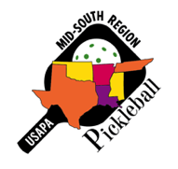
MID-SOUTH REGION NEWSLETTER
May, 2017

We have three newly appointed ambassadors to introduce this month: Jin Lee (College Station, TX), Robert Redmond (Flippin, AR), Kate Williams (Rogers, AR), and Shaun Buckles (Enid, OK).

Jin is a visiting professor at Texas A & M, and has been playing PB almost two years. He has helped organize and run the TX A & M PB Invitational as well as the Brazos Valley Senior Games. Jin is also involved with the Korean community in the Bryan/Col Station area and has taught PB to Korean students and faculty members in the community. He plans to work in South Korea in the fall of 2017 and wants to initiate PB programs on university campuses, workshops in the communities, with the end result being to lay the foundation for growth of PB in that area.

Robert has been playing about a year and a half. After finding no places to play in his immediate area…and then driving 84 miles to Branson, MO to play once a week, he built his own court at his house. He now has about 20 friends and acquaintances who come to his house 2-3 times a week to play. He has taught all of them and more keep showing up. (What a surprise). He recently ordered a ball machine so that they can begin doing drills. Robert wants to keep spreading the word by networking with his group. Nearby Mountain Home, AR has a youth center where they play twice a week. He plans on coordinating with them and hosting clinics to introduce new players to the sport and enhance the skills of all players.

Kate has been playing about two and a half years. She has helped do a demo for PE teachers in the Bentonville school district and is in the process of organizing a clinic for players in her area. While traveling in another state, Kate saw all different generations playing together (parents & teens, mother & daughter, couples in their 60s, kids and their grandmother) and that vision really drove home what a great sport it is to bridge the generational gaps. She hopes to do the same in her immediate area. She also wants to get hold of the fringe groups playing nearby and bring them into the fold.

Shaun has been playing abut a year and a half. He has introduced PB at the ‘Y’ that he works at and has helped DA Vicky Noakes with a clinic. Shaun has also started PB at a local church gym.Recently, he introduced PB at a Country Club/Tennis Facility and started a league there as well as conducting a tournament.

As you can see, we have four very interesting new ambassadors. Please welcome them to our ambassador family.

Mike Morgan (Germantown, TN) attended a family get together in Oxford, MS and you can see the multi-generational thing at work below.

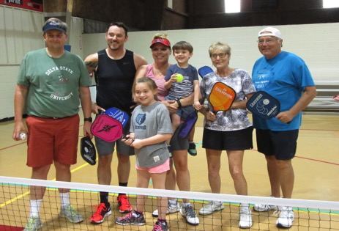

Gordon Irwin (Copperas Cove, TX) reports that he has had successful meetings with the local ‘Y’ and are willing to host PB three days a week (10am-1pm) and even give evening time one day a week. He has also found possible courts at a local elementary school. (Great work, Gordon).

Mike Goldberg (Houston, TX) announces two new venues are now open for PB. The First Methodist Church of Houston’s Quillian Rec Ctr has four indoor courts and three outdoor pavilion courts.
The Judson Robinson Jr Community center has recently marked two PB courts.

Gayle Glesson (Floresville, AR) has been approved for a USAPA grant. She is using the grant for a net system and floor tape to be used at the local community Event Center for a demo tournament. Following that, she plans on teaching PB in a day camp format for 9-13 year olds at the summer youth program, which will be held at the same site. Many of those kids are at-risk. She also has plans for getting seniors involved as well. (Way to get the kids involved, Gayle).

Pat Heurtin (St Francisville, LA) sends this photo of a warm-up period just prior to the beginning of her local ‘fun’ tournament.
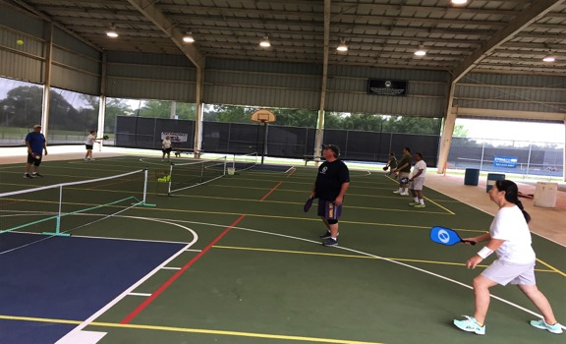
Pat’s PB Club has also been granted from the local school board to use an elementary school gym for morning play during the summer. She has a meeting scheduled with the school superintendent and other to discuss ways to use that space and time to teach PB to some middle school kids.

Mary Hodge (Richardson, TX) shares that their local ABC affiliate contacted the Richardson Senior Center to inquire about having PB on its Good Morning, TX program. Fellow ambassador David Wilmot, an employee of the Center, followed up and the presentation will be done at the local PB venue next month.

Chuck Flanagan (Georgetown, TX) sends the link to their ever-popular club newsletter called Kitchen Talk:
https://www.sctexas.org/Files/Library/27380/2017-MAY_KITCHEN_TALK.PDF

Mary Payne (left) passed her recent evaluation to become a Certified Ref during a Cedar Park tournament. Congratulations, Mary. I believe this is the first physical evaluation in our region. Thanks to the evaluation committee.
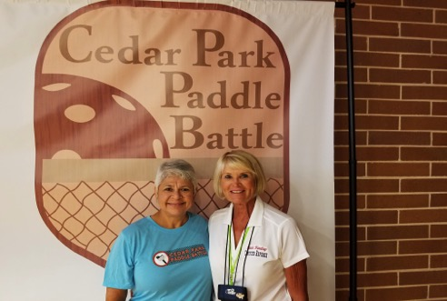

Vicky Noakes (OK City, OK) notes that the OK ambassadors are working hard at training not only new players, but new refs as well. She and four OKC PB Club members went to Stillwater, OK to start training about 15-20 players from that city and also Ponca City to referee at their tournaments.

Nathalia Hiatt (Ponca City, OK) set up a demo for family and friends in in Ponca City and surrounding area that would like to learn how to play PB.

New ambassador Clayton Edwards (Ada, OK) also has a demo clinic set up at the Chickasaw Nation Wellness Center Gym in Ada to get that town started playing PB.

Sherry Prince (Edmond, OK) has agreed to help train players at the new OKC Maps 3 Senior Health and Wellness Center.

David Stefan (Bryant, AR) has also been approved for a USAPA grant:
Right now, in the Little Rock area, there are only two places to play pickleball. A brand new community center facility has just opened in Benton (just southwest of Little Rock) called Riverside Park. I am a USAPA Ambassador in Bryant (seated right between Little Rock and Benton). I have been in communication with Benton Parks Recreation Supervisor for more than a year about starting a pickleball program once the new center is opened. We had a meeting on May 4th and they have agreed to start a morning pickleball program this summer, most likely in July. The Director at Riverside Park is being bombarded with requests for programs and he has been somewhat reluctant to give the approval. However, we have had donations of paddles from Paddletek and Selkirk and it is my hope to use the grant money to purchase nets that will be donated to Riverside Park. The Recreation Supervisor has indicated that the lower the cost of this program, the more support it will likely garner from the administration. We have successfully grown pickleball in neighboring Bryant with less support from
the Parks Department there. In a couple of years, the Benton Parks has plans for a phase 2 of their building plan which will include a tennis facility and the Recreation Supervisor has indicated that there is a possibility of including pickleball in the plans for those courts. This grant will give us a foot in the door of a brand new community with huge growth potential. Growth in Benton will also help to feed growth in Bryant and in Little Rock.
(An excellent, detailed, request. Good work, David).

The Central District Senior Olympic Games PB tournament will again be held in Natchitoches, LA on July 29 & 30. For registration info, email Lila Lodrige at (lila@hughes.net).

This month, I participated in the well-run SSIPA tournament in Denton, TX at Robson Ranch. Although there were a few raindrops, the event accomplished everything it could have wanted to do. Several ‘locals’ put up (and put up with) a few of the non-locals. Thanks for your generous hospitality. As always, it was great seeing ‘old’ friends and making new ones. That is absolutely the best thing about tournaments.

We head for Birmingham soon to begin a marathon of a tournament …900+ players, in six days using 25 courts. I hope to see many of you there. We will have some really long days, and nights. The only thing I can promise is that we should not get rained out.

Although I only send these newsletters to our ambassadors, you are certainly welcome, and encouraged, to share any part, or all, with players in your area. Additionally, the newsletter can always be found on the Mid-South website: http://midsouth.usapa.org/

tom

